### This content intended for:

http://www.centralglassutah.com

### Image

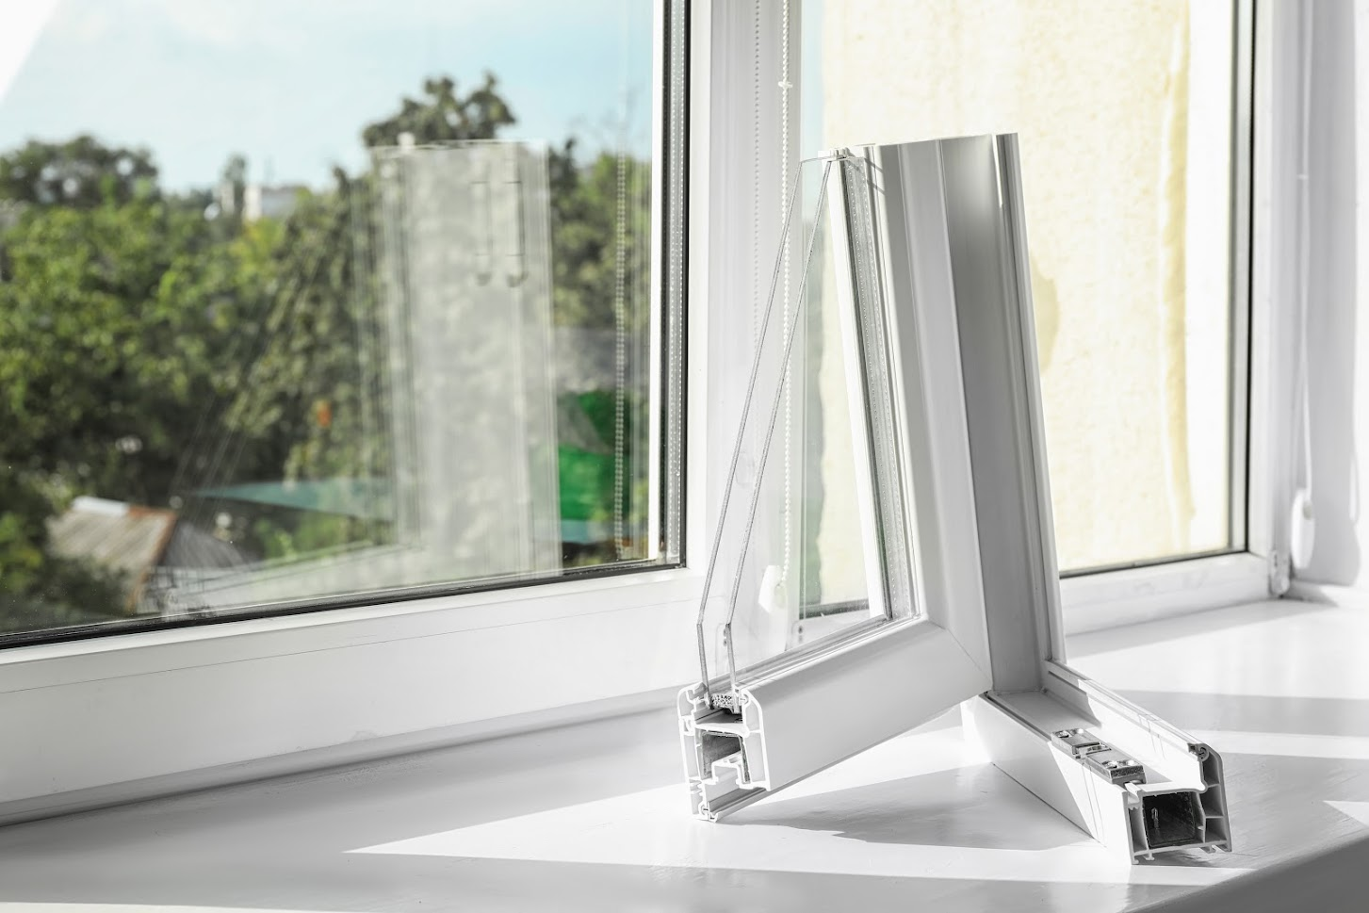

##### (Adding this image to your blog post will help to increase user engagement)

### Page Title

Pros and Cons of Vinyl Windows | Central Glass Company

### Meta Description

Many people opt for vinyl windows these days. Discover the pros and cons of vinyl windows to ensure they will meet your needs and fit your lifestyle.

### Title / H1

Pros and Cons of Vinyl Windows

### Body

More people opt for vinyl windows these days because of the energy and cost savings they offer. They are made of a durable, hard plastic material (polyvinyl chloride, or PVC) and provide superior insulation.

Vinyl windows, like any other product, are not for everyone. Some homeowners have discovered that they would want other options. That is why so many options are available.

With window upgrades, gather as much information as possible before making a final decision. When considering vinyl windows, make sure they will meet your needs and fit into your lifestyle. Discover the pros and cons of vinyl windows.

**Pros of Vinyl Windows**

Vinyl windows are right for many people. What advantages do these windows offer that make them so attractive?

They Are Easily Available

Vinyl windows are easy to manufacture. They are thus available in the market at a competitive price. Vinyl is less expensive than fiberglass and stronger than wood. Hence, your supplier will work within your budget to provide and install the vinyl.

They Are Energy-Efficient

Vinyl windows come with hollow cavities that you can fill with insulation. If you're concerned about heating and cooling costs, vinyl windows are a sure bet to cut your home utility bills.

They Offer Many Fabrication Options

Vinyl is a versatile material that you can customize to meet your desired home design. Whatever the shape or size of your window or door, you can craft a frame to fit.

They Don’t Require P​ainting

Vinyl windows are available around the market in different colors. All you have to do is select the color that matches your decor. You can also opt for a more neutral shade to give your home a warm feel.

They Offer Lower Costs

Compared to wood and glass fiber, vinyl windows are the less expensive option. Due to the low cost of production, sales and installation are inexpensive.

They Are Durable and Low Maintenance

The things you invest in at home, such as replacement windows, should last. If not well maintained, materials such as wood are prone to rot. Hot and moist conditions can make wood expand and contract, resulting in stress on the window. Vinyl is the opposite. It resists dirt, mold, and rust. Vinyl repels insects like termites, which bore into wood and cause damage.

**Cons of Using Vinyl Windows**

Vinyl is not right for everyone. What are some reasons you shouldn’t consider vinyl windows?

Vinyl Is Not Painted

If you are high on painting surfaces around your property, vinyl doesn't give you that option. Once painted, the paint peels off within a short time. Paint can also result in chips, flakes, and cracks on vinyl, giving it an unpleasant look. You can instead go for a neutral color that harmonizes with your décor.

Vinyl Has Varying Quality

With such a high demand for vinyl today, it has variation in its quality. Before purchasing, ensure your window manufacturer and installer offers quality services. Low-quality vinyl is prone to cracking and warping. Research and consult with your contractor to ensure you receive a high-quality product. All this while getting value for your money.

Vinyl Has Poor Temperature Regulation

Vinyl windows are prone to heat loss during winter due to their inability to insulate well. Vinyl can tear when exposed to harsh weather conditions. This results in distorted shape and flexibility. Consult your professional supplier to know which material is best for your location.

Now, imagine getting customized shapes and sizes for windows and doors for your property. All this comes at a friendly price that will work within your budget. Are you based in the SLC and West Utah Valley area? Do you need professionals who offer remodeling and home improvement services? [Contact us](https://centralglassutah.com/contact-us/) today to know more about our services.

### HTML

<p>More people opt for vinyl windows these days because of the energy and cost savings they offer. They are made of a durable, hard plastic material (polyvinyl chloride, or PVC) and provide superior insulation.</p>

<p>Vinyl windows, like any other product, are not for everyone. Some homeowners have discovered that they would want other options. That is why so many options are available.</p>

<p>With window upgrades, gather as much information as possible before making a final decision. When considering vinyl windows, make sure they will meet your needs and fit into your lifestyle. Discover the pros and cons of vinyl windows.</p>

<p><strong>Pros of Vinyl Windows</strong></p>

<p>Vinyl windows are right for many people. What advantages do these windows offer that make them so attractive?</p>

<p><em>They Are Easily Available</em></p>

<p>Vinyl windows are easy to manufacture. They are thus available in the market at a competitive price. Vinyl is less expensive than fiberglass and stronger than wood. Hence, your supplier will work within your budget to provide and install the vinyl.</p>

<p><em>They Are Energy-Efficient</em></p>

<p>Vinyl windows come with hollow cavities that you can fill with insulation. If you're concerned about heating and cooling costs, vinyl windows are a sure bet to cut your home utility bills.</p>

<p><em>They Offer Many Fabrication Options</em></p>

<p>Vinyl is a versatile material that you can customize to meet your desired home design. Whatever the shape or size of your window or door, you can craft a frame to fit.</p>

<p><em>They Don’t Require&nbsp;P​ainting</em></p>

<p>Vinyl windows are available around the market in different colors. All you have to do is select the color that matches your decor. You can also opt for a more neutral shade to give your home a warm feel.</p>

<p><em>They Offer Lower Costs</em></p>

<p>Compared to wood and glass fiber, vinyl windows are the less expensive option. Due to the low cost of production, sales and installation are inexpensive.</p>

<p><em>They Are Durable and Low Maintenance</em></p>

<p>The things you invest in at home, such as replacement windows, should last. If not well maintained, materials such as wood are prone to rot. Hot and moist conditions can make wood expand and contract, resulting in stress on the window. Vinyl is the opposite. It resists dirt, mold, and rust. Vinyl repels insects like termites, which bore into wood and cause damage.</p>

<p><strong>Cons of Using Vinyl Windows</strong></p>

<p>Vinyl is not right for everyone. What are some reasons you shouldn’t consider vinyl windows?</p>

<p><em>Vinyl Is Not Painted</em></p>

<p>If you are high on painting surfaces around your property, vinyl doesn't give you that option. Once painted, the paint peels off within a short time. Paint can also result in chips, flakes, and cracks on vinyl, giving it an unpleasant look. You can instead go for a neutral color that harmonizes with your décor.</p>

<p><em>Vinyl Has Varying Quality</em></p>

<p>With such a high demand for vinyl today, it has variation in its quality. Before purchasing, ensure your window manufacturer and installer offers quality services. Low-quality vinyl is prone to cracking and warping. Research and consult with your contractor to ensure you receive a high-quality product. All this while getting value for your money.</p>

<p><em>Vinyl Has Poor Temperature Regulation</em></p>

<p>Vinyl windows are prone to heat loss during winter due to their inability to insulate well. Vinyl can tear when exposed to harsh weather conditions. This results in distorted shape and flexibility. Consult your professional supplier to know which material is best for your location.</p>

<p>Now, imagine getting customized shapes and sizes for windows and doors for your property. All this comes at a friendly price that will work within your budget. Are you based in the SLC and West Utah Valley area? Do you need professionals who offer remodeling and home improvement services? <a href="https://centralglassutah.com/contact-us/">Contact us</a> today to know more about our services.</p>